**Figma first design**

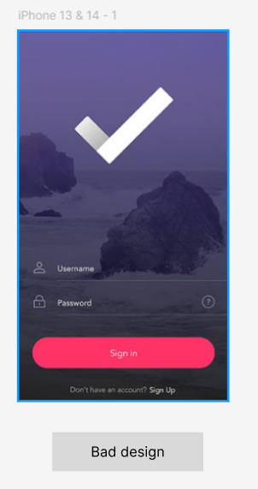

This is a bad design for a login page extracted from google images.   
This bad design has to be turned into a good design using Figma software.

* Reasons for this design to be considered bad:

1. The username and password are not bright enough for the user to understand
2. The background picture embedded is not brighter
3. It does not give a positive approach to welcome the user
4. A welcome message is missing.
5. The tick logo is just bland white.
6. The edges are sharp, which makes it look old-style

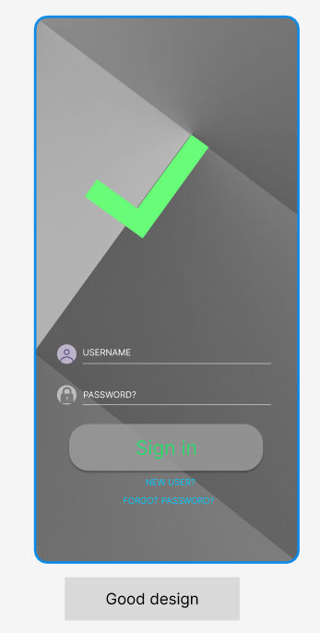

This is the good design created using Figma software with reference to the bad design mentioned previously.

* Reasons for this design to be considered a good design:

1. The username and password are very much bright
2. The sign in button is enlarged for more specific contact area of user
3. The background picture is brightened but not too much and does not cover the interaction of user with the buttons.
4. The tick logo is given a bright green colour to approach the user in a positive welcoming way .
5. The edge is curved, making it look much more trendy.

* Side by side comparison of the login pages mentioned:

